FORM FIVE MID-TERM EXAMINATIONS 2025
ITILIMA SECONDARY SCHOOL
PHYSICS 1
TIME: 3 HRS
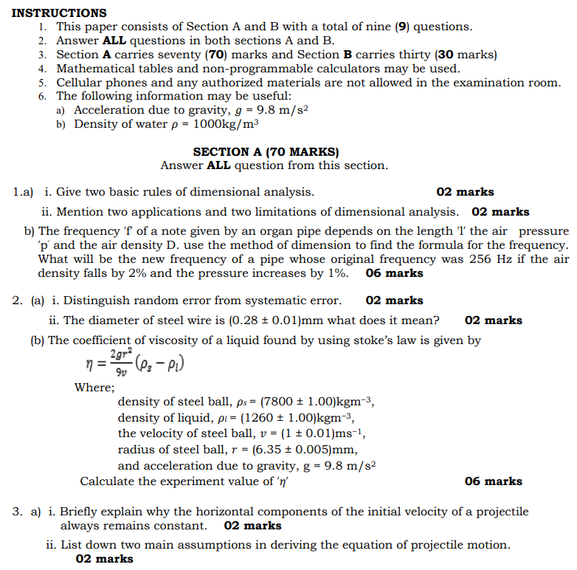
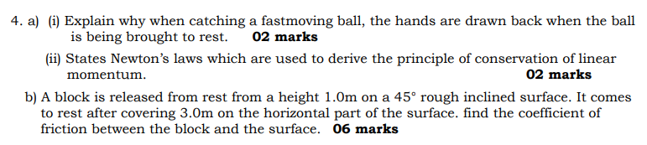
5. (a) A horn of frequency 900 HZ is sounded by a car travelling towards a cliff and normal to the cliff with a velocity of ${20ms}^{-1}$. Calculate the beat frequency of the horn sound as heard by the car driver. Velocity of sound in air is ${320ms}^{-1}$ (04 marks)
(b) (i) Briefly explain the effect of the fringe width when young’s apparatus is immersed in a water (02 marks)
(ii)In a Newton’s rings experiment, the diameter of the 15th dark ring was found to be 0.59 cm and that of the 5th ring was 0.336 cm. If the radius of curvature of the Plano-convex lens is 100 cm, calculate the wavelength of the light used. (04 marks)
(c) (i) Explain any two uses of Polaroid. (02 marks)
(ii) Light of wavelength 600nm is incident normally on diffraction grating of width 20.0 mm on which ${10.0×10}^{3}$ lines have been ruled. Calculate the angular positions of various orders. (03 marks)
